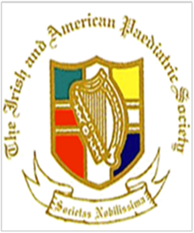

IAPS in Boston

Irish American Paediatric Society 53rd Annual Conference  **Save the Date: September 18-21, 2022/**

[**Irishamericanpaediatricsociety@gmail.com**](mailto:Irishamericanpaediatricsociety@gmail.com)

**727-858-7711**

Hear some of the latest research, CME accredited. Call for abstract open June 1- closing July 1.CME accredited. Gather with old friends and make new friends. A grand old time for all.



