**SAVE THE DATE**

IAPS in DUBLIN

**Irish American Paediatric Society**

**56th Annual Conference   
March 25-29th 2025**

[**www.irishamericanpeds.org**](http://www.irishamericanpeds.org)

**Founders Lectures / Keynote Speakers:**

**Thomas Cone Lecture:**

Overview of Targeted Neonatal Echocardiography - Prof. Patrick McNamara - Director of the Division of Neonatology at the University of Iowa

**Fred Burke Lecture**:

The Changing Face of Cystic Fibrosis; From Basics to Long Term Care in the Modulator Era - Prof. Basil Elnazir – Consultant Paediatric Respiratory Medicine – Children’s Health Ireland at Tallaght

**Bill Kidney Lecture:**

Overview of the Newborn Behavioral Observations System and its Theoretical Underpinnings - Assistant Prof. Lise Johnson – Chief of the Division of Newborn Pediatrics

**](https://www.irishneonatalsociety.ie/wp-content/uploads/2023/01/HyattCentricHotel.jpg)**

**Hyatt Centric Hotel, Dublin 1**

Room Bookings: <https://www.hyatt.com/en-US/group-booking/DUBCT/G-UUU3>

Joint meeting with the Irish Neonatal Society 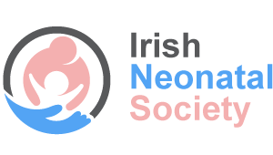

15th Irish Neonatal Research Symposium on Friday 28nd March 2025

*https://www.irishneonatalsociety.ie/*

***THE IRISH & AMERICAN PAEDIATRIC SOCIETY TRAVEL AWARDEE offering* travel awards to registrars/ residents for the meeting based on abstract submissions.**

**For questions, contact Regina Mirabella at** [**Irishamericanpaediatricsociety@gmail.com**](mailto:Irishamericanpaediatricsociety@gmail.com)